Prescriptions in an AgLeader InCommand

- On the map screen of the InCommand, select the rate in the right-hand corner if you do not see the product toolbox.

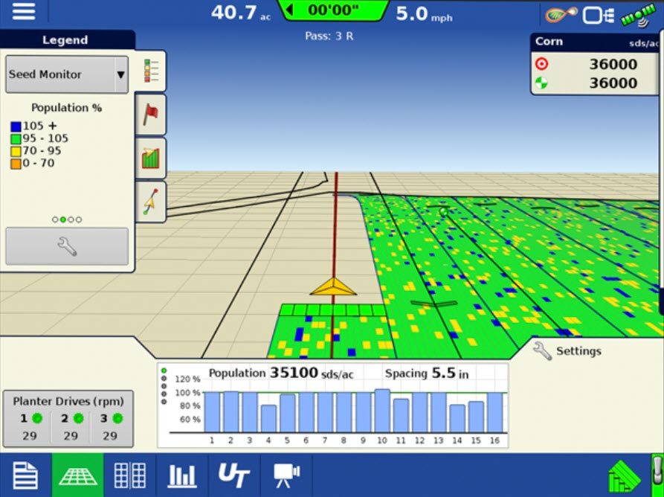

- Select the Wrench button.

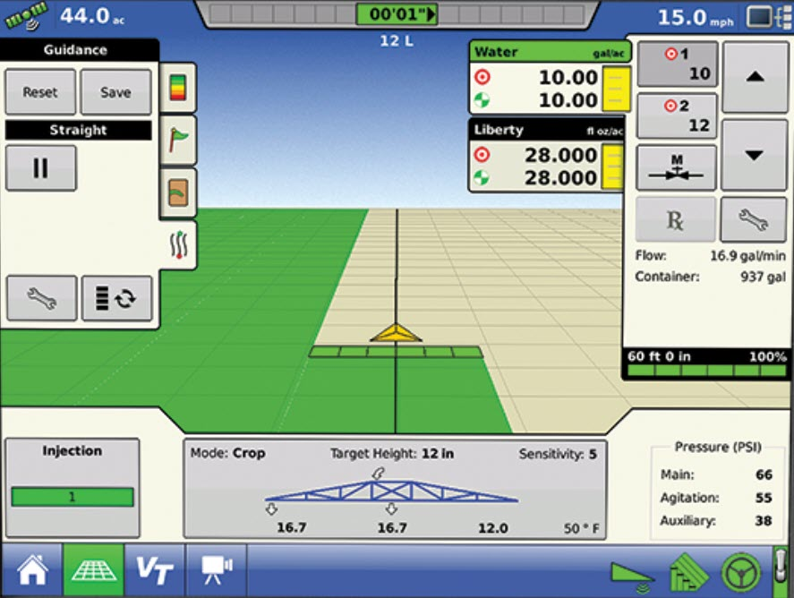

- On the Rate Control Screen, select the Load Prescription button. Split planter would have Product 1 and Product 2.

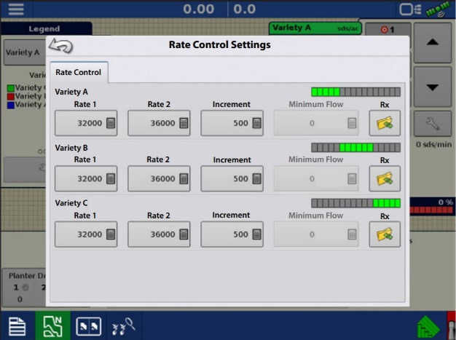

- You will highlight the correct AgSetup, irx or shp file and press the “>” button.
  - You may need to continue to open up the folder to find the prescription by using the “+” button.
  - You will know you are successful when you see a preview of the Rx in the lower right-hand part of this screen.

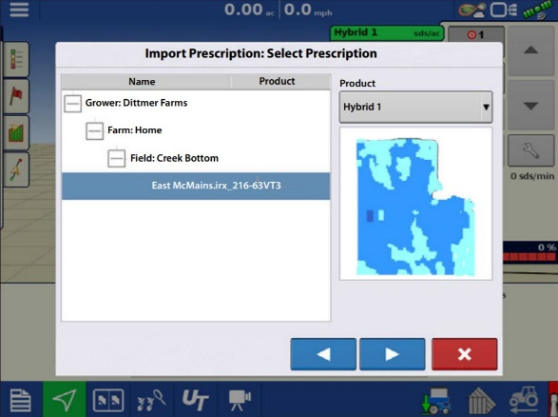

- Optional: Make any needed modifications.

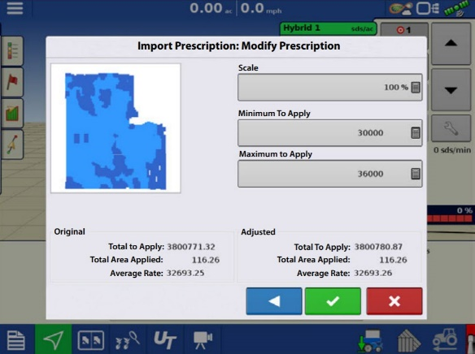

- When you return to the Rate Control Settings screen, the prescription rate is now shown on the screen. The Load Prescription button has disappeared and in its place is the Remove Prescription button, which resembles a minus sign.

- You should now see a map similar to this and you can change the legend by adjusting on the left-hand side (product, rate, etc.).

