Prescriptions in an Pro700

- Click the Work Condition button, then click the “Layer” tab at the bottom:

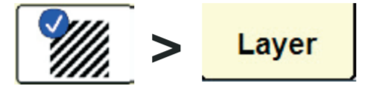

- Create or Select the Work Condition, Layer, and Product Information.

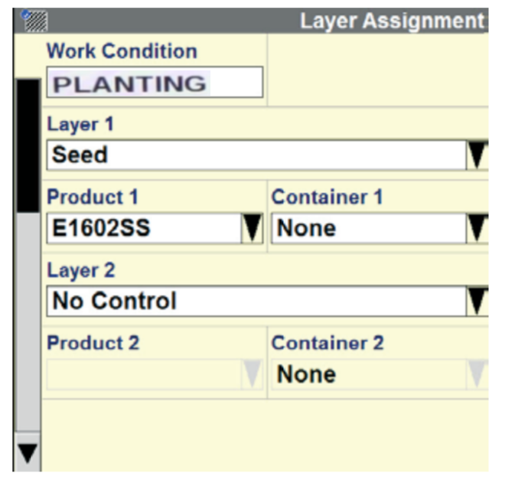

- Select the Back button.

- On the Home screen, select the “Performance” button then find your “Rx Setup” tab.

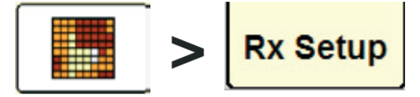

- Make sure the Auto Reload Rx is set to Enabled. Verify the Grower, Farm, and Field is correct.

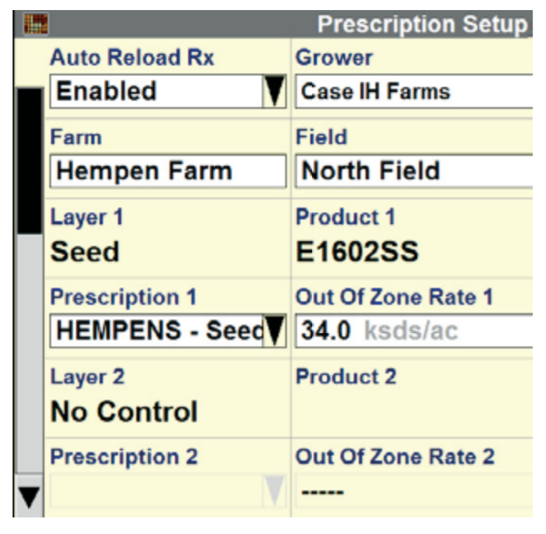

- Select the Prescription from the dropdown.

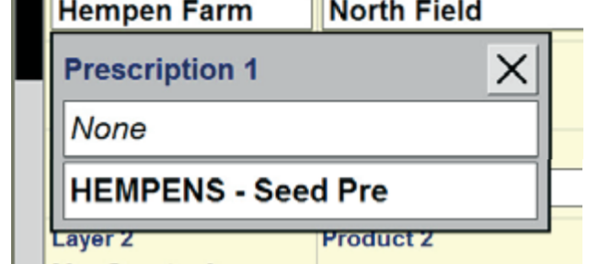

- Set/adjust the Out of Zone Rate, if you need to.

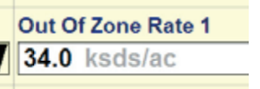

- To view your prescription, click the “Back” button to return to the Home page and select the “Run” button and navigate to the Run screen that shows your map.

- Jump to Step 13, if the map is showing. If it is not showing your prescription, follow Steps 10 - 12.

- Select the Layer button.

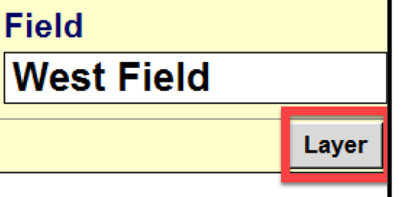

- Then select the product that you are applying from the Data Type dropdown and make sure that the Rx Style is set to Color. Press OK.

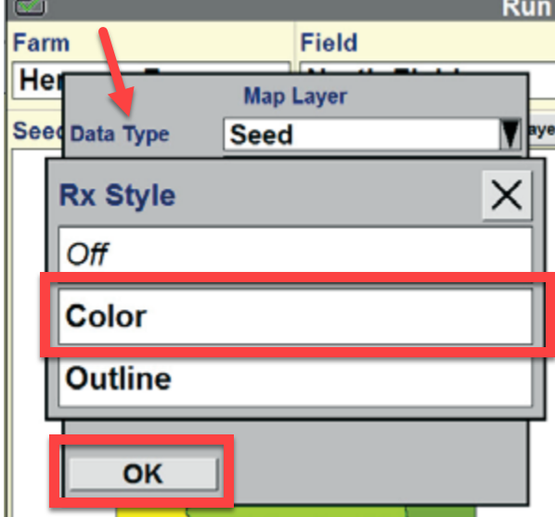

- Adjust the Legend, if needed.

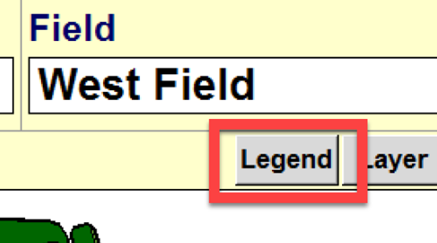

- Make sure that Seed Ctrl is set to Auto “(A)” and if it is on Manual “(M)”, click the Seed Control box to change it and click the “Enter” button.

