KINZE Blue Vantage: Loading Planting Prescriptions
- Insert USB
- Select MANAGE

- Select PRESCRIPTION AND BOUNDARY FILES
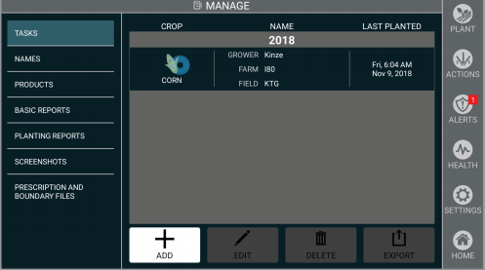
- Select IMPORT
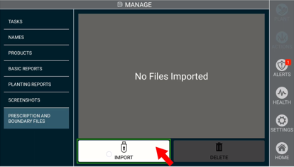
- You can select just the field(s) you want to load or Select All
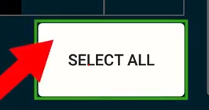
- Select the checkbox
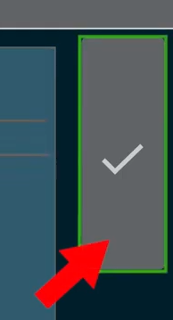
- The Prescription files are now Imported into the display
- Go back to the Home screen
- Select PLANT

- Select ADD
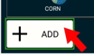
- Select the PRESCRIPTION box on the lower left-hand corner of screen
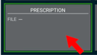
- Select the Prescription you want from the list, make sure it is highlighted once selected
- Select the checkbox
- You will now see the prescription in the PRESCRIPTION box in the left-hand corner of the screen
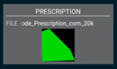
- The POPULATION box in the center of the screen will show you are using an Rx
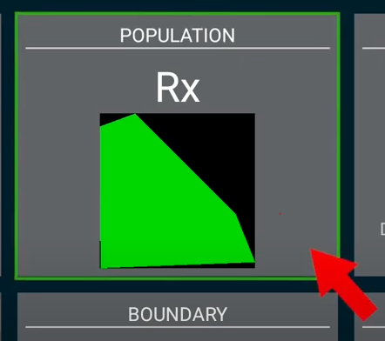
- Select PLANT- you are ready to go!
